CS303: Software Engineering

**Project Deliverable 4: Component Diagram + ER Diagram**

**Due Date:** 1900Hrs, December 14, 2020 **Group Name: __**Cavalry**_____**

**Group Members: Shahrose Khaliq (13L-4322), Uzair Ahmed Bhatti (17L-4010), Muhammad Saqib Kamran (17L-4154), Muhammad Khuram Niaz (17L-4238), Ali Haseeb (17L-6326)**

This phase requires the students to provide their component-to-component interface and a component diagram for the whole system. In addition, to make sure that all data fields have been identified, provide a complete ER diagram.

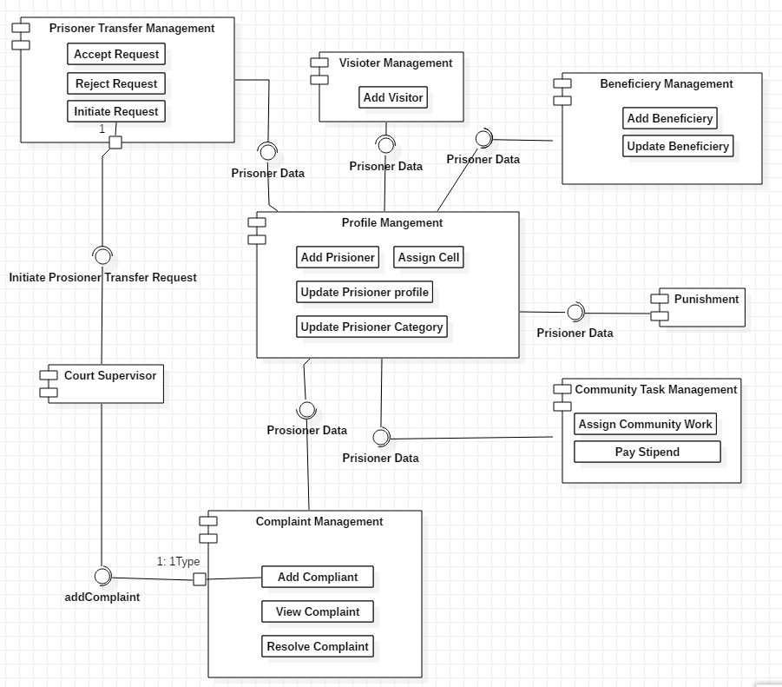  
  
 Figure 1: Component Diagram   
The figure above represents the component diagram for the Prisoner Management System.

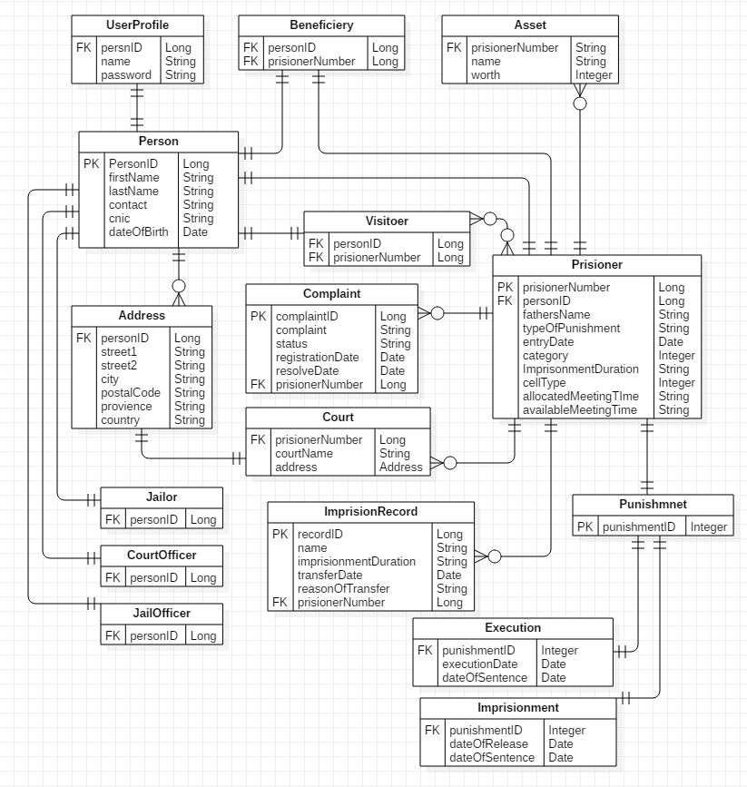  
 Figure 2: ER Diagram   
  
The figure above represents the ER diagram for the Prisoner Management System.